Image and Story Permissions Form

MK Education Pty Ltd occasionally uses customers/staff images and stories for promotional or training purposes. We also love to celebrate your achievements and progress by sharing your image/ story to your friends, family and the community.
We would like your permission to use images and/or story of you in publications. The images will remain the property of MK Education Pty Ltd and will only be used by MK Education for the purposes as listed below.
Newsletters, Displays, Presentations, online social media including MK Education’s facebook page, Instagram and in the future, our Website.

Customer or Staff members Name: Bryan Botterill_____________________
Address: 6 / 7 Wastell Street, Northcote______________________
Phone: 0423379146____________________________________
Email: bryanbotterill@gmail.com______________________________

Terms and conditions
MK Education agrees not to use images/ stories that may be deemed as adverse or defamatory to the customer/staff whose image/ story is being used. MK Education will not use any image/story for commercial gain. MK Education also agrees not to provide any image or story to any other person or organisation without the permission of the person named above or the permission of the person who authorises this consent form.
I agree to MK Education using my image/story for the purposes listed. I agree to the Terms and conditions above and I have also had this form explained to me in plain English.
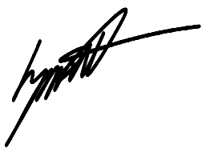
Signature: ___________________________________ Date: ___03/05/2025____
(or signature and name of legally authorised person)

