STUDENT - PRODUCT ASSESSMENT TASK

PRODUCT ASSESSMENT TASK
Task Number | 3 of 3 . | Task Name | Program Review Report
National unit/s code | CHCCCS007 | National unit/s title | Develop and Implement Service Programs
National qualification code | CHC52015 | National qualification title | Diploma of Community Services (Case Management)
RMIT Program code | C5345 | RMIT Course code | HWSS6101C

Section A - Assessment Information
Duration and/or due date:

Task Instructions
Summary and Purpose of Assessment
This assessment task is two of four assessment tasks you need to complete satisfactorily to be deemed competent for this unit.
The objective of this assessment task is to demonstrate your ability to review a service program and to suggest and plan for improvements.
Assessment Instructions
For this task you need to review the program that you designed and your own performance, and prepare a program review report.
This is an individual task but you will be allocated time during class to prepare the report.
What
- Read the following
- Assessment Three Scenario – Youth Mentoring Program Review Information(Section D)
- Yarra Community Centre Program Review Report (Section E)
- Make sure you have collected and analysed the Feedback Forms that you handed out to your team members for Assessment task 2.
- Using information from the Scenario (Section D) and also the results from your Feedback Forms complete the template Yarra Community Centre Program Review Report (Section E)
- Upload the completed Yarra Community Centre Program Review Report to Canvas as a Word or PDF document.
Don’t forget to read the Assessment Criteria so you can understand what exactly you’ll be assessed on.
Where
This assessment will take place within the classroom environment and out of class, in your own time
How
You will be assessed against the criteria listed in the marking guide in Section B of this task. To achieve a satisfactory result, you will need to address all criteria satisfactorily.
Please ask your teacher to help you clarify the task’s requirements and any of the instructions.
Conditions for assessment
- You must complete the task by the due date.
- Please make arrangements with your assessor at least one week prior to the assessment due date if you feel you require special allowance or allowable adjustment to this task.
- If the assessment is a group-based activity each student will be assessed individually against all assessment criteria
- This task is to be completed in your own time and during time provided in class.
- This assessment need to be uploaded to canvas.
- You will have the opportunity to resubmit any product deemed unsatisfactory (one resubmit is allowed per unit).
- To achieve a result of 'satisfactory' you need to follow all step as listed above.
- You will be assessed as satisfactory or not satisfactory
- You can appeal the assessment decision according to the RMIT Assessment Processes.
Instructions on submitting your project/portfolio/report
Each student needs to submit Canvas:
- A copy of your completed Yarra Community Centre Program Review Report as a Word Document or PDF

Equipment/resources students must supply: |  | Equipment/resources to be provided by RMIT or the workplace:
- Computer and relevant software  - Class notes  - Feedback Form from Assessment two |  | - Hard copies of unit materials and the student version of this assessment task OR access to soft copies  - Computer and internet access (if required)

Section B – Marking Guide
Below is a checklist for how this assessment task will be judged as satisfactory or not satisfactory.
Key Criteria that must be demonstrated
Criteria for Assessment |  | Satisfactory |  | Comment
 |  | Y | N | Comment
1 | You reviewed data and information to prepare a program review report that provided a description of the program.
2 | You reviewed data and information to prepare a program review report that listed the review period and date of review.
3 | You reviewed data and information to prepare a program review report that explained the review’s methodology.
4 | You reviewed data and information to prepare a program review report that explained the program’s effectiveness against objectives
5 | You reviewed data and information to prepare a program review report that explained the effectiveness of external stakeholder relationships.
6 | You reviewed data and information to prepare a program review report that described the outcomes of your own performance analysis
7 | You reviewed data and information to prepare a program review report that identified areas for improvement or modification.
8 | You reviewed data and information to prepare a program review report that included two recommendations for program improvements and an action plan to implement these recommendations.
9 | You reviewed data and information to prepare a program review report that included one recommendation to improve your own performance as a team member and an action plan to implement this recommendation.

Section C – Feedback to Student

Has the student successfully completed the task? |  | Yes No
Feedback to student:

Assessor Name | Date

Section D – Assessment Three Scenario – Youth Mentoring Program Review Information
The mentoring program has been running for six months. It’s now time for a review of the program.
Here are some figures and feedback you’ve collected about the program for the review:
- The number of total relationships by month six exceeded the target by 20 per cent.
- The number of mentors and participants who rated that they experienced extremely positive (or great) relationships was less than anticipated. However, only by five per cent. This was due to:
- an incident of poor communication between a YCC team member and a participant, where the participant wasn’t contacted with notice about a mentor’s need to reschedule the session
- an incident where a mentor received counselling from RMIT after she took a participant to an event and drank alcohol with a participant, as she believed that this behaviour exposed the student to uni life.
- The RMIT Program Manager provided positive feedback on the relationship between YCC and RMIT, including the use of Google to exchange documents. But, she wanted to make sure that the responsibilities of RMIT mentors is clearly communicated not only at induction but also every so often to remind them of their responsibilities.
- The RMIT Program Manager made the suggestion that RMIT student from different program areas might be interested in becoming mentors.
- Your team mates have completed and returned to you the Team Member Feedback Performance Form for you to analyse.

Section E – Yarra Community Centre Program Review Report

Program
Yarra Community Centre (YYC) runs a variety of programs for the community and its youth. Our Youth Mentoring Program will support many students in year 11 and who attend our homework club, to make an efficient transition into tertiary studies by providing each of the students with a RMIT student mentor.
Youth mentoring program supports will include:
- Monthly mentoring session
- Career advising
- Campus tours
- Events
- Guest speakers

To be eligible for the Youth Mentoring Program, the student must be part of The Homework Club at Yarra Community Centre and be enrolled in Year 11 studies.

Review Period and Date
Six-month review, 9 December 2021

Methodology
The program was assessed effectively in several different ways. Students completed a survey at the end of each week to identify if their immediate needs were met. Mentors also provided feedback every term to identify if the program were running effectively and if there were any areas of improvement that could be implemented.
The program has an open-door policy surrounding the program, where clients, stakeholders and staff can have an open dialogue and provide feedback for the program. Written performance reviews were also conducted for staff.

Results
Our main objective was to gain strong relationships between VCE students and RMIT mentors, forming a minimum of 20 student to mentor relationships over the course of a six-month period. As the data shows, we have exceeded that number and gained 24 students to mentor relationships. (See diagram 1 below)

Quantitative:

When the mentees were asked if the program met their needs, the majority said it did (15) although 4 said it did not and 4 said they were unsure. (See diagram 2 below)

When mentees were asked how satisfied they were with the program, 12 mentees said they were extremely satisfied, 7 very satisfied, 4 neutral and 1 unsatisfied. (See diagram 3 below)

When asked if the mentees had a positive relationship with their mentors, most said they found their relationships to be extremely positive. Although this was 5% less that anticipated. (See diagram 4 below)
This was due to poor communication by a YYC member and participant, and an incident with a mentor who did not remain professional.

When the mentees were asked the statement “I would recommend this program to others”, most said they strongly agreed (15), and 2 mentees said they did not agree. (See diagram 5 below)

Qualitative:

We had great feedback from the mentees.

One mentee said, “Having a mentor was awesome, I got tons of support and gained enormous amount of confidence through the program.”

Another said, “This program was a great steppingstone before entering University.”

And some highlighted “the mentors should undergo more training, my mentor seemed lazy and confused about what they should be doing.”

Feedback from Stakeholder
The RMIT program manager provided positive feedback regarding the program and the relationship between YYC and RMIT, including using google toe exchange documents back and forth.
An area of improvement was noted for the better communication regarding responsibilities that the RMIT mentors have. Feedback was given to implement reminding mentors about their responsibilities not just during induction but ongoing through the running of the program.
A suggestion was also made “that RMIT students from different program areas might be interested in becoming mentors”.

Team Member Performance Feedback

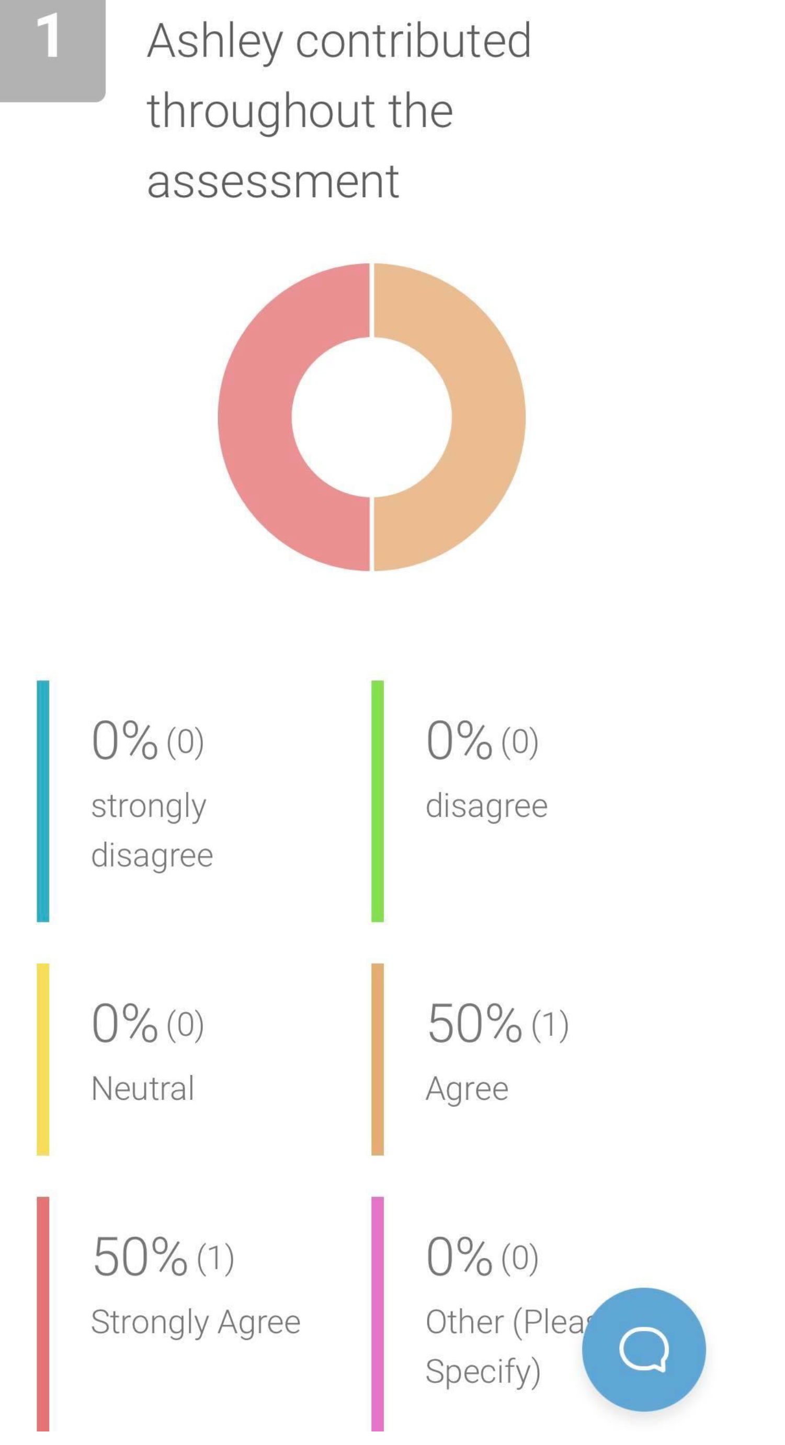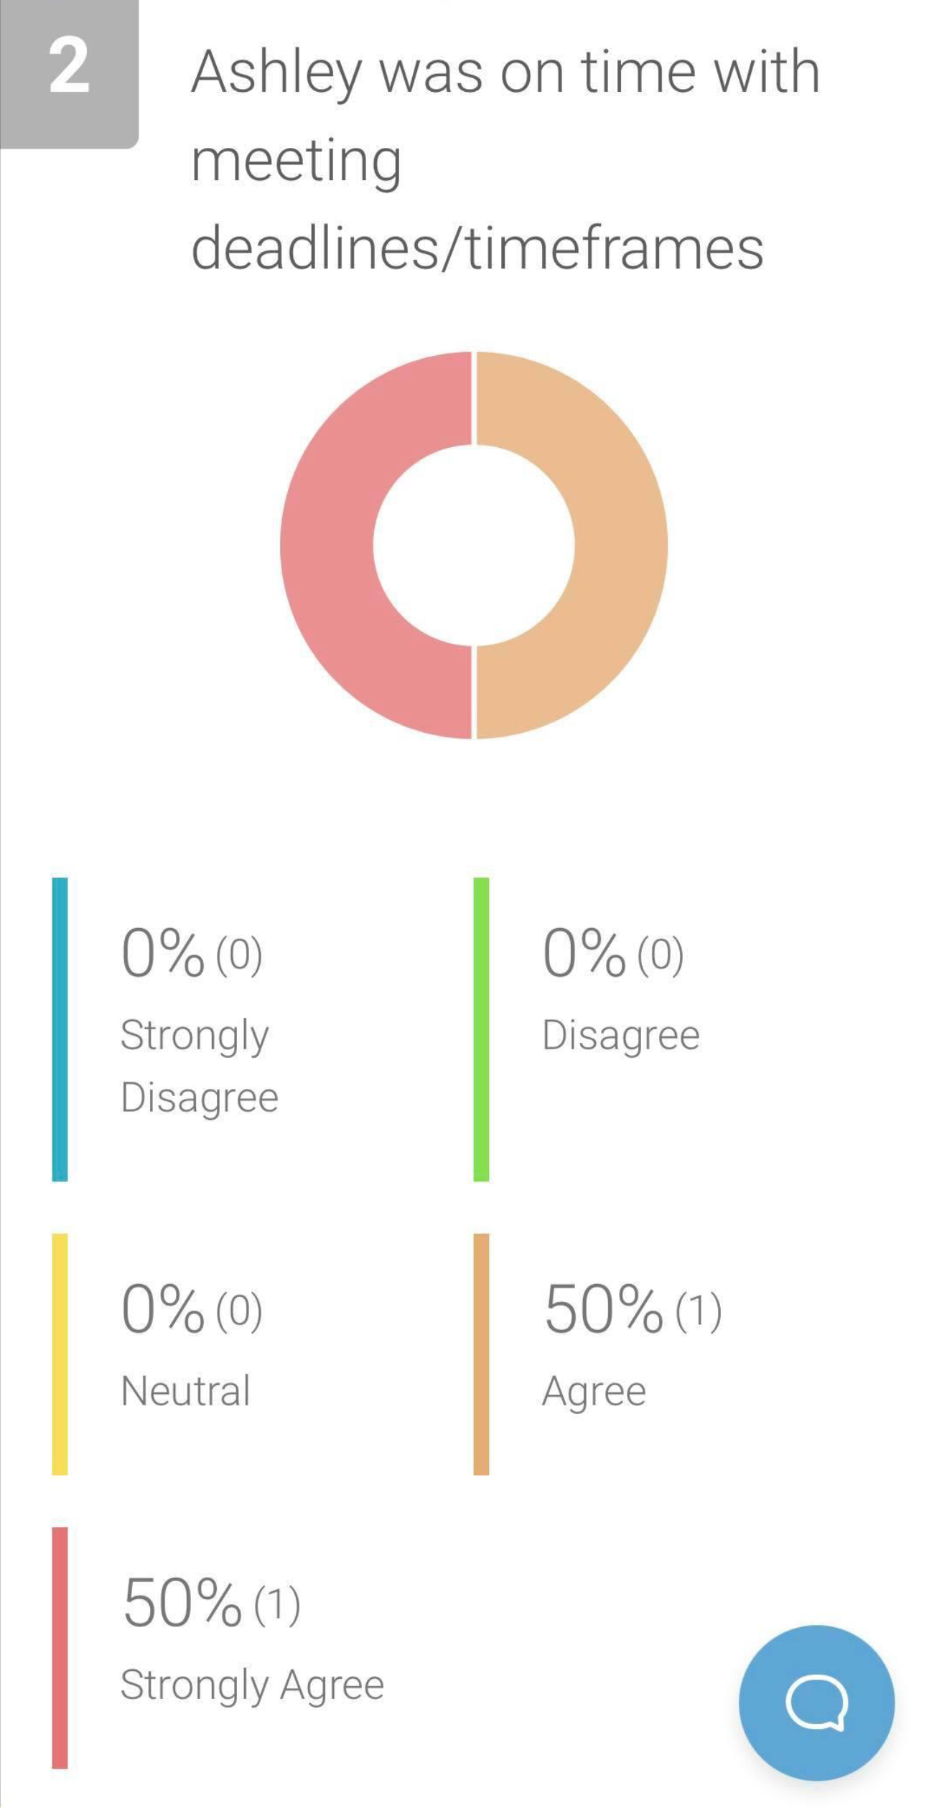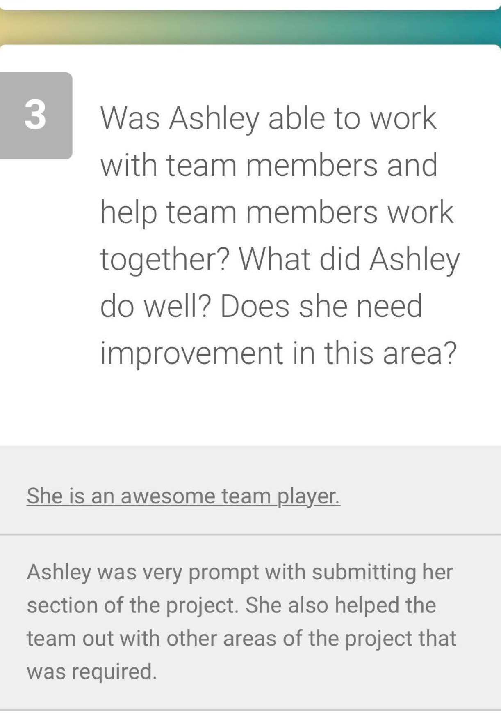

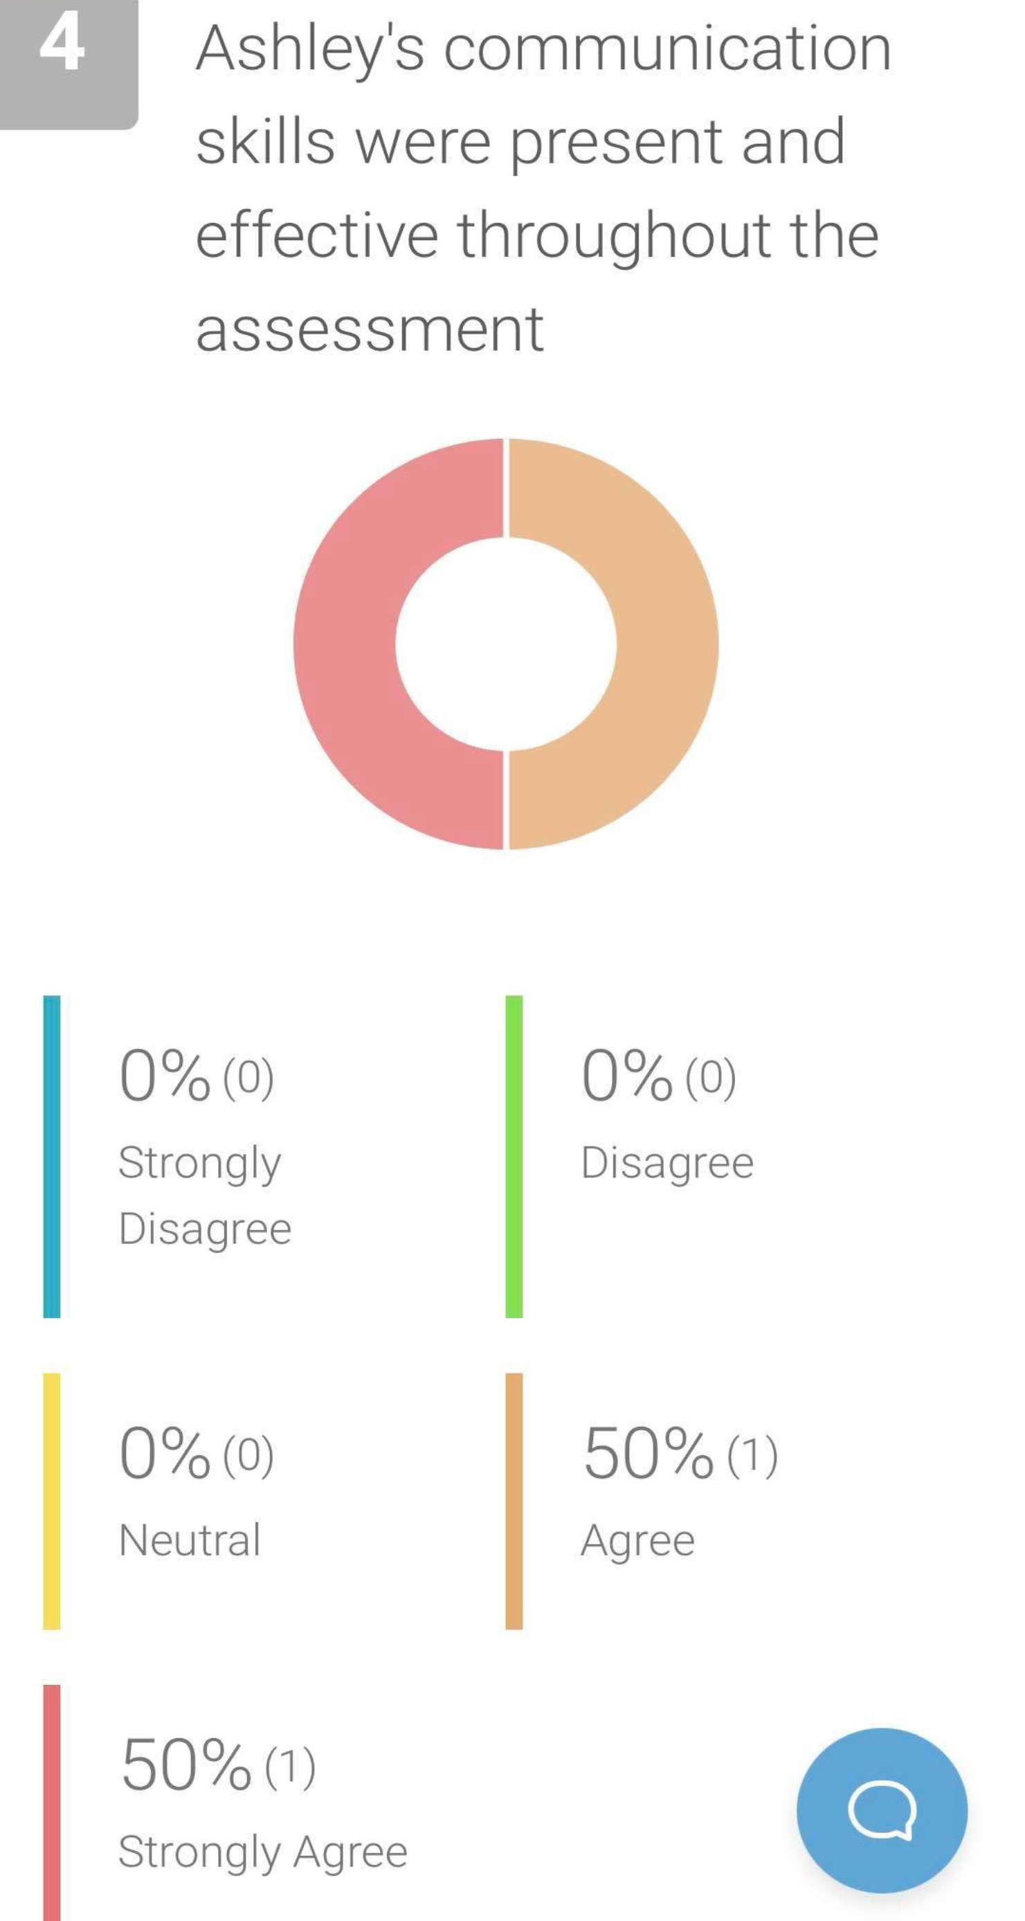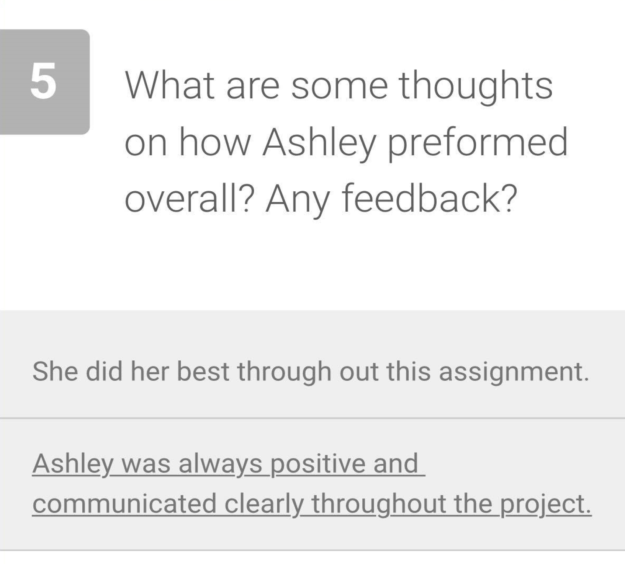

Areas for Improvement

This should include information about program improvements and own performance improvements.
Program Improvements
Making sure RMIT mentor roles and responsibilities are clearly communicated throughout the duration of the running of the program
Opening mentoring positions to other RMIT students from different programs who are interested
Provide longer training sessions for mentors
Set clear boundaries between mentors and mentees
In terms of personal improvement, I did receive positive feedback from my colleagues, but I believe I can improve on understanding the clients and stakeholders and doing research in other services programs to gain greater insight.

Recommendations Action Plan
Identify and describe at least two recommendations to implement program improvements and one to improve your own performance. Use the tables below to develop the action plans for the recommendations and their implementation.

Program Improvements
Recommendation | Steps to Implement | Resources Required | Responsibility | Timeframe
Provide longer training sessions for mentors | - 5-day induction and training  - Clear and concise training booklets | - A space big enough space for 5-days  - Food and drink for 5-days | Stacey | 5-days
RMIT mentor roles and responsibilities are clearly communicated throughout the duration of the running of the program | - Monthly meetings with mentors  - Weekly mail reminders on roles and responsibilities | - Space for weekly meetings  - All mentors email addresses | Stacey | Ongoing

Personal Performance Improvements
Recommendation | Steps to Implement | Resources Required | Responsibility | Timeframe
Understanding the clients and stakeholders | - Holding focus groups with clients and stakeholders | - A Space to hold focus groups | Me (Ashley) | 1-year
Research in other services programs | - Speak to the head of other service programs  - In my own time research on my computer other service programs | - Computer  - Phone | Me (Ashley) | 1-Year

